DEPOT-WIDE MINOR CONSTRUCTION
MULTIPLE AWARD INDEFINITE DELIVERY INDEFINITE QUANTITY (IDIQ)
MULTIPLE AWARD TASK ORDER CONTRACT (MATOC)
TOBYHANNA ARMY DEPOT

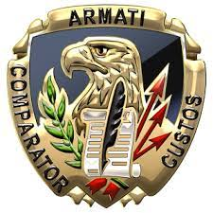

VOLUME I - TECHNICAL
July 28, 2021

Submitted to:
Jacqueline D. Ramsey
ACC-APG, TOBYHANNA DIVISION
11 Hap Arnold Blvd.
Tobyhanna, PA 18466
jacqueline.d.ramsey.civ@mail.mil,

Submitted By:
Harry Brown

Miami Wiipica, LLC
1950 Roland Circle Drive
Reston, Virginia
hbrown@mn-e.com
Cell (609)230-4425

DUNS: 117007074
Cage Code: 8B6Y9
EIN: 35-2652385

Table of Contents
1. Volume 1 - Technical 1
A. Introduction & Compliance Matrix 1
A.1 Statement of Work Compliance 1
1.1 Section 1 - Subfactor a: Bonding Capacity 2
1.2 Section 2 - Subfactor b: Safety Program 3
1.2.1 Accident Prevention Plan (APP) 3
1.2.2 Experience Modification Rate (EMR) 4
1.3 Section 3 - Subfactor c: Quality Control Plan (QCP) 5
1.3.1 Quality Objectives 5
1.3.2 QC Organization & Staffing 7
1.3.3 QC Activities 10
1.4 Section 4 - Subfactor d: Contract Management Plan (CMP) 16
1.4.1 Corporate Structure 16
1.4.2 Contract Execution Plan 19
1.4.3 Project Organization 28
1.4.4 Scheduling Methodology 33
1.4.5 Plan for Providing Additional Resources 34
1.4.6 Provision of Qualified Personnel Quantity 35
1.4.7 Evaluating and Selecting Architect/Engineering (A/E) Firms 36
1.5 Attachments 37
1.5.1 Attachment 1 – Key Personnel Resumes 37
1.5.2 Attachment 2 – Sample Quality Reports 38

1.0 Volume 1 - Technical

1.1 Section 1 - Subfactor a: Bonding Capacity
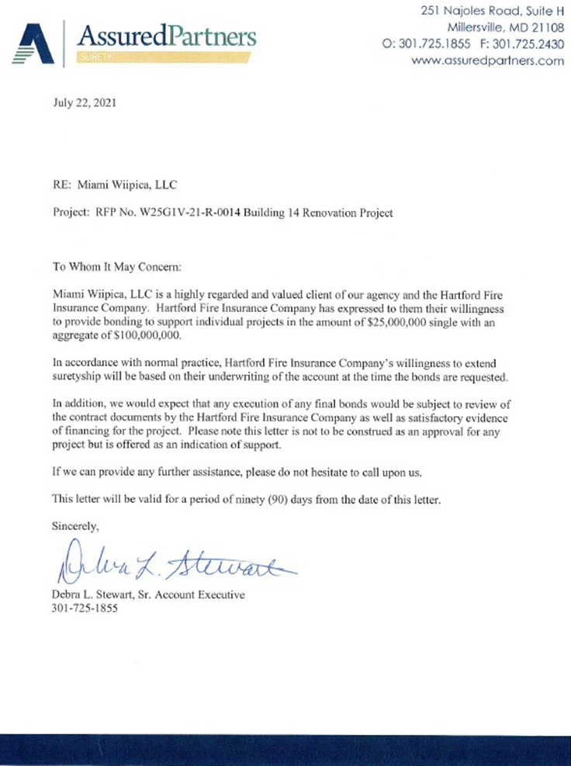
Bonding
Wiipica Miami, LLC meets and exceeds the bonding requirement posed by Solicitation No. W25G1V21R0014
- $25 million single award
- $100 million aggregate

1.2 Section 2 - Subfactor b: Safety Program

1.2.1 Accident Prevention Plan (APP)
for the Building 14 TO in accordance with the requirements ofthe Unified Facilities Guide Specifications (UFGS) 01 35 26 and compliant with United States Army Corp ofEngineers Engineering Manual 385-1-1 (USACE EM385) Safety Standards and Controls requirements (see Attachment 3). This APP will be used in the Base MATOC Award and Building 14 seed project TO evaluation.
Call Out Box for Discriminator / Highlight

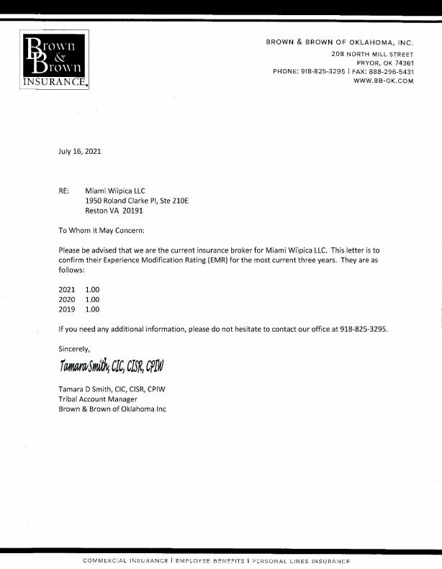
1.2.2 Experience Modification Rate (EMR)
Miami Wiiipica, LLC has a current ERM rating of 1.00, due to its date of incorporation.
Miami Wiipica, LLC will not be eligible for an ERM rating until next year. This entity was formed and added to the insurance coverage in August of 2019. Since the ERM is calculated using three years of historical data (excluding the most current expired term), the Miami Wiipica, the ERM remains < 1.00.
Insurance Contact
Name: Tamara Smith
Brown & Brown Insurance, Oklahoma
208 N Mill Street
Pryor, OK 74361
Email: tsmith@bb-ok.com
Phone: 918-825-3295

1.3 Section 3 - Subfactor c: Quality Control Plan (QCP)
Miami Wiipica follows a standard Quality Contrrol Plan (QCP) for all construction projects. The Plan is written in accordance with te requirements of the Unified Facilities Guid Specification (UFGS), compliant with the United States Army Corp of Engineers (Manual 385-1-1) and will be instituted for the Tobyhanna Army Depot (TYAD) projects.
Wiipica’s Quality program, based on the Unified Facilities Guide Specification and the USACE Engineer Manual Safety Standards and Controls Requirements, will ensure that the Quality Plan will meet and exceed the governments expectations for the Building 14 seed project and future TO proposal submissions.
A critical part of Wiipica’s approach to Quality Management (QM) has been the adoption of key external industry standards of practice, in preparation for an ISO 9001:2000 certification this year (2021).
This has served to drive the development of strong, well-documented internal procedures that define key processes throughout the Miami Nation Companies. Particularly effective, and rated as best in class, are Wiipica’s Document and Record Control and their Project Management (PM) processes for Engineering and Construction.

Figure 1 – Document and Record Control and Project Management processes are Best in Class
•Document and Records Control
•Internal Audit and Corrective/Preventive Action
•Engineering
- Product Development (Hardware/Software)
- Engineering Change/Configuration Management

1.3.1 Quality Objectives
Wiipica’s objectives for quality are based on always meeting the UFGS-01 45 00.00 .20 Construction QCP requirements and has fostered a strong sense of value and pride in achieving Customer Satisfaction. Wiipica believes that through strong relationships and delivering projects that meet and exceed all customers requirements and expectations, we have a reputation for having ethical and forthright quality planning and execution. At the project level, Wiipica has:
- Effective, well-documented procedures to identify projects and customers with the highest potential for collaboration and partnership. These are programs for which Wiipica can provide the highest level of Customer Satisfaction, not only with superior technology and reliability, but by building strong relationships with the entire Customer Team.
- Project Team/Field Investigation Team/Project Management Office (PMO): Wiipica’s strength is that our approach to QM matches that of the US Government guidelines, and staffs the project teams to provide a high degree of process control. The Wiipica approach include QM:
- Commitment to the entire project:Technical, Project/QM, Procurement, Contracts, Site Management, Service/Transition, Governance, Political, and User Agencies.
- Project Management Professional (PMP) certified project personnel; trained in the industry standards set by the Project Management Institute (PMI).
- A proven PM Plan Methodology: aligns with our processes with that of PMI.
- QC representatives that are integrated into the Project Team and respected as an independent customer advocate.
- Quality trained PMs that proactively executes and enforces QC activities and constructively engages the QC activities performed independently by Wiipica’s organization.
- Strong Project Team preventive processes like Design Review/Submittal, Document/Records Control, Configuration Management, Change Management, and Issues/Risk Management.
- Close Partnerships between Wiipica and Subcontractors, with well documented Quality Standards.

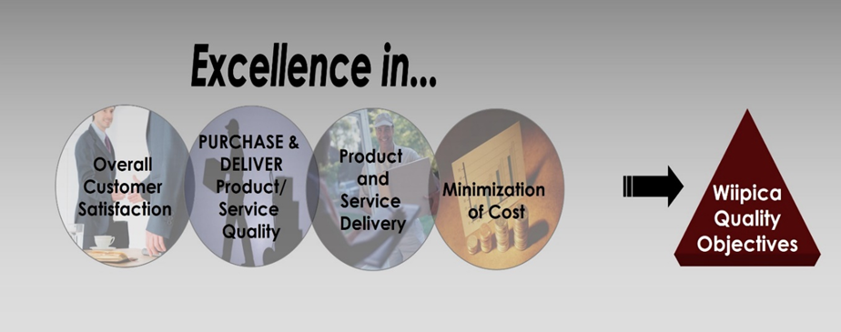
Figure 2 – Wiipica strives for Excellence in Achieving Quality Objectives
Wiipica’s government performance welcomes strong customer involvement through methodically and transparently communicating at every phase of a project. In addition to PMBOK® training, project personnel are trained by the TL9000 Quality Management Systems Measurement Handbook. Knowledge and Training are valued by Wiipica’s upper management and allows each member of the team to perform checks and balances over the major processes.
These procedures provide a high level of proactive QC, made more effective by independent semi-annual audits by our corporate QC professionals, and galvanized by Wiipica’ reputation for integrity.
The key project level processes; Project Management, System Engineering and Operations and Maintenance processes:
Wiipica “is a reliable and conest contractor”
-Soe Lynn, PM, Contracting Officer, US Air Force

Figure 3: Quality is Valued in all Process Categories
Wiipica Quality is Categorized by Three Main Process Phases
- Project Management
    - Contract Review and Execution
    - Project Plan and Schedule Development
    - Project Installation Process
    - Subcontractor Management
- Systems Engineering
  - Site Survey and Requirements Procedures
  - System (HVAC, Electrical, etc.) Installation Process
  - System Documentation
  - System Acceptance Testing Procedure
  - Generating Project-Specific Instructions Process
- Operations & Maintenance
  - Site Audit Procedure
  - Training Class/Instructor Evaluation
  - Training Instructor Certification
  - Course and Module Development

1.3.2 QC Organization & Staffing
Components of the Quality Staff Plan for TYAD
a. | A description of the QC organization, including a chart showing Project lines of authority and acknowledgment that the QC staff will implement the three phase control system for all aspects of the work specified.
b. | The names, qualifications (in resume format), licenses/certifications, duties, responsibilities and authorities of all project management to include the PM, QCM, Site Safety and Health Officer (SSHO), Site Superintendent (Super) and any other employees acting in a lead or otherwise managerial position.
c. | A copy of the letter to the QC Manager (QCM) signed by an authorized official of the firm which describes the responsibilities and delegates sufficient authorities to adequately perform the functions of the QCM, including authority to stop work which is not in compliance with the Contract.
d. | Procedures for scheduling, reviewing, certifying, and managing submittals, including those of subcontractors, offsite fabricators, suppliers, and purchasing agents. These procedures will be in accordance with Section 01 33 00 Submittal Procedures
e | QCM will work with the GDR on control, verification, and acceptance testing procedures for each syste; and will include the test name, specification paragraph requiring test, feature of work to be tested, test frequency, and person responsible for each test.
f. | Procedures for tracking preparatory, initial, and follow-up control phases and control, verification, and acceptance tests including documentation
g. | Documented procedures will track construction deficiencies from identification through acceptance
h. | Standard reporting procedures, including proposed reporting formats
i. | QCM will keep a list definable features of work. Each is a task will be defined as separate and distinct from other tasks, and has separate control requirements (as identified by different trades or disciplines). Although each section of the specifications can generally be considered as a definable feature of work, there are frequently more than one definable features under a particular section. This list will be agreed upon during the coordination meeting.

Figure 4: Duties, Responsibilities and Authorities of QC Personnel

1.3.2.1 Wiipica Project Organization
Miami Wiipica, LLC
Program Manager
Cecil Whitlock
.
General Manager
Harry Brown

Architect and Design
BBIX
Alan Shaffi
QC Manager.
Troy Bollinger
Safety Manager
Charlie McGill

QCDR
Brad Norris
Design Manager
BBXI
Alan Shafii

Figure 5: Wiipica’s Preliminary Project Organization Chart for TYAD

*QCDR = QC Designated Representatives

TYAD
Superintendent
TYAD
QC Manager

TYAD
Site Safety
TYAD PM
Onsite Supervisor
Excel Construction
Steve Rainone
Government Designated Representative

1.3.2.1.1 Quality Control Manager
Once Notice to Proceed (NTP) on a project is received, the Wiipica Manager will forward the NTP to the QCM. Wiipica proposes a highly skilled QCM team for TYAB. Our Quality Control Manager, Troy Bollinger is a US military trained Systems Enginee with 30 years of progressive construction site knowledge. Mr. Bollinger has managed the Quality Control success of several projects for Wiipica; Arlington National Cemetery, POFF Federal Building Renovation, and renovations for the NSA Office of the General Council. Figure 6, below, lists the expectations of Wiipica for their QCM in support of the PM. See Section 4 for description of Roles and Responsibilities expected of the PM..
Troy Bollinger
30 years of experience
Als, see Appendix A - Key Peresonnel Resumes for details of his relevant job history, and Section 3.0 – Past Performance for details of the managed projects.
Once Notice to Proceed (NTP) on a project is received, the PM will forward the NTP to the QCM.

Figure 6: Priority Roles & Responsibilities of the Quality Control Manager in Support of the PM onsite
Ensuring Acceptance of QC Plan
Maintain an effective QC (QC) system and compy with the Contract Clause “Inspection of Construction”
Follows USACE Construction Quality Management standards.
Recommend new or improved quality control methods, procedures and standards
Submitting the QC Plan 10 days follProjectg notice to proceed (NTP) and responsible for making any changes to the plan and the personnel and submitting Changes to the GDR for acceptance
Coordination Meeting
Final Plan must be submitted 15 days prior to the Coordination Meeting
A mutual understanding of the Quality Control Plan (agreement will be signed by both parties)
Maintain the CQC Staff at Full Strength at all Times
Submits changes to staff for acceptance and manages changes seamlessly
Maintain and Document all QC Requirements and Activities
Provides a listing of assigned QC activities for performance by the prime contractor, subcontractors, and suppliers.
Maintains set of accurate contract drawings as required
Conducts routine quality audits to ensure work is progressing per the contract specifications
Resolves construction issues; coordinate activities with subcontractors, and project schedules to achieve on-time completion
Conducts weekly production meetings, which facilitated stronger communication and the ability to resolve critical issues
Ensures adherence to established quality standards on site
Prepares and distributes all necessary project administrative documents including 3-week look ahead schedule, material delivery tickets, investigation reports
Proposes corrective actions to improve compliance with quality specifications
Works closely with PM in development and management of punch list to minimize work at the end of projects
Maintains quality reports and supervise the processing of data including testing and inspection reports
If the contractor delegates QC duties, the plan must indicate how he will assure the effectiveness of the QC efforts.
Include a list of duties, responsibilities and authorities of each person in the QC organization.

1.3.2.1.2 Proposed Alternate QC Manager (AQCM)
As an experienced PM, Charlie McGill will act as the Alternate QC Manager (AQCM) for the TYAD projects. Mr. McGill has over thirty years of project experience on various construction projects; such as marine structures, medical facilities, marine structures and more. He will utilize this knowledge and skills in field supervision and quality control to support the Quality Manager onsite and off. See Appendix A - Key Peresonnel Resumes for details of his relevant job history.
Charlie McGill
30 years of Quality Control Experience

1.3.2.1.3 QC Designated Representative Lead (QDCR)
Wiipica’s proposed lead QCDR is Bradley Norris and will be available to cover quality construction activities at all sites. Mr. Norris is a USACE certified Construction Quality Manager (CQM) and 365 Emergency Management (EM) training manager; as well as as Marine Corp Lean Six Sigma Yellow Belt. His extensive experience (21+ years) with the United States Department of Defense (DoD) makes him an excellent candidate to for the TYAD projects. He will report directly to the QC Manager and keep accurate reports. See Appendix A - Key Peresonnel Resumes for details of his relevant job history.
Bradly Norris
CQM

1.3.3 QC Activities

1.3.3.1 Quality Control Plan
Onsite, the Wiipica PM, with the aid of the QCM, will evaluate the nature, specific details and complexity of the projects and develop a project-specific QCP that will include a project specific organization chart; definable features of work and a project-specific submittal register.
QC Activities are high level quality planning and surveillance activities performed by the QM. Figure 7 describes the QA Activities and their benefits to the TYAD and the project.
- QC Plan (QCP)  - Product Surveillance  - Process Surveillance (QC Activities)  - Support for TYAD Oversight and Surveillance  - Development and Reporting of Metrics | - Well-thought-out, ethical strategies and methods to meet stated requirements and unstated expectations. Ongoing planning.  - Corrective Actions/Preventive Actions  - Process Improvements  - Quality Project Completion

Figure 7: Utiling on Onsite Quality Control Manager – Features and Benefits

1.3.3.2 QC Activities and Benefits to
QC Activities are performed by the Project Team and subcontractors to control all aspects of the project. The QM monitors these activities to ensure compliance. Figure 8 describes the QC Activities and their benefits to the TYAD and the project.
The Quality Control Management Approach exhibited by MTS/Wiipica has allowed the government to locate gaps in the internal and external process and the ability to correct those findings. The contractor located audit risk factors and recommended corrective action.
-Jessica Greene, Contracting Officer, DHA

Figure 8: Additional Activities and Benefits
QC Activities | Benefits to the TYAD and Project
Project Management | - Schedule Management.  - Issue/Risk Management  - Change Management, including subcontractors  - Requirements Management, including subcontractors
Document/Records Control | - Approval for adequacy.  - Re-approve as necessary.  - Revision status identified.  - Relevant versions available at points of use.  - Legible and identifiable. Unintended use prevented  - Export controls of proprietary information and data
Design Control | - Design performed by qualified personnel  - TYAD System Requirements Review (SRR)  - TYAD Electric and HVAC  - Management: Engineering Change Proposals.
Purchasing/Supply Management | - Capable, accounFigure suppliers and subcontractors  - Schedule and cost control
Process Control | - Deliverables that meet requirements  - Implementation issues escalation process  - Warranty Review
Inspection, Testing | - Documented Test Methodology  - Robust inspection, testing, and recordkeeping.  - Capable inspection/test equipment
Control of Nonconforming Product | - Identification and removal or control-in-place

1.3.3.3 QC Management of Subcontractor and In-house Personnel Performance
Wiipica’s objective on all task orders (self-performed or subcontracted work) is to provide quality
projects safely and on time. In order to manage expectation, certain standards remain constant:
- All executed work will be tracked and evaluated for performance.
- We track and evaluate performance of all subcontractos. Poor performing subcontractos may result in the removal from the subcaontractor database and will not be considere on future projects.
- The workload of prospective subcontractors is evaluated prior to entering into a contractual agreement on a project.
- We will not enter in a contractual agreement with subcontractors that are no capable of meeting the project schedule.
- In the event that the subcontract fails to adhere to our quality control guidelines, the subcontract will be terminated and reported to the government.
- A project schedule is developed for each project with input from all stake holders.
- All prospective sucontractors involved with each project are required to meet the schedule and corrective measures are also in place for lack of meeting the deadlines.

3.3.4 Testing Plan
In order to identify and maintain quality throughout the life of a project, Wiipica follows the USACE CQM guidelines for identifying quality and where there is a deficit, the risk is immediately mitigated. The QCP will include a testing and monitoring plan.

Figure 9: Wiipica follows the USACE-QCM guidelines and monitors control in the pre-defined phases
USACE Guidelines for QCM
Prepatory Phase | - Notify the government at least 24 hours in advance of beginning the preparatory phase (meeting with QC Manager, Superintendent and other CQC personnel as applicable)  - Review the applicable specification and reference codes required by the government.  - Review of the Contract drawings  - Check to assure that all materials and/or equipment have been tested  - Examination of the work area  - Examination of required materials, equipment, and sample work  - Review potential hazard analysis to assure safety requirements are met.  - Identify Repetitive Deficiencies and report  - Document quality observations and add to the daily CQC report
Initial Phase | - Compare work to compliance and contract requirements  - Verify adequacy of controls in place to achieve contract compliance  - Analyze the level of work and verify that if meets accepFigure standards  - Review safety plan and adjust as necessary to activity hazards  - Give notice to the government that the initial phase has been analyzed and defined (24 hours)  - Activity Hazard Analysis (AHA) to assure safety requirements are being met, proper contraols are in place, etc.  - File QC Report with the Government
Follow-up Phase | - Before startin a new feature of the work, daily checks are completed to assure control activities (control testing). These daily checks are logged in the CQC documentation
Testing | - Capability Checks and rechecks
Inspection | - Punch- out all CQC documentation is analyzed to create a punch list of items which do not conform to the approved drawings and specifications, as required by paragraph DOCUMENTATION.
Final Acceptance | - The Contractor's QC Inspection personnel, plus the superintendent or other primary management person, and the Government Designated Representative (GDR)'s Representative is required to be in attendance at the final acceptance inspection.

3.3.4.1 Inspections
Quality control starts with each worker. Each subcontractor is responsible to ensure that his workmen install materials and equipment in accordance with project requirements.
Quality control inspections will be conducted daily during construction for each project to ensure the work is installed as contracted and submitted. Wiipica’s onsite QC and QCDR will perform these inspections and perform the following tasks:
Figure 10: QC and QCDR Inspection Tasks
Inspection Tasks
1 | A review of the contract requirement and submittal information
2 | Confirm all equipment and materials have been submitted and approved
3 | Confirm that all required testing procedures are in place
4 | Compare actual field progress to scheduled field progress
5 | Examin materials, equipmen, and samples to be sure they conform to approved submittal and contract obligations
6 | Check for any damaged or defective materials
7 | Verify dimensional requirements and conformity to coordinated shop drawings
8 | Verify that as-built information is being properly maintained
A Construction Quality Inspection Report will be completed daily. The onsite QC will maintain a listing of nonconforming items and a documented deficiency log. Visual confirmation of the of all corrections will be made on a daily basis and documented.
The TYAD PM and construction inspector may conduct ineterim inspections prior to covering inspected work. This will include insulation, electrical, plumbing, earthwork density testing, subgrade proof rolling, concrete field sampling and testing.

3.3.4.2 Identifying Quality Deficits and Mitigating the Risk
The quality control plan will be implemented on all work; self-performed and subcontracted. All non-compliance work or deficiencies will be noted on the project deficiency log and on the quality inspection daily report. Daily reports are turned in to the government PM on the next business day and the deficiency log is submitted weekly. The project deficiency log consists of:

Figure 11: Project Deficiency Log Components
1 | Task order number and project name
2 | Onsite QC name
3 | Date and time of finding of deficiencies
4 | Description of deficiencies
5 | Subcontractor and foreman name
6 | Action Taken
7 | Method and deadline for correction
8 | Correction Date
Every time a deficiency is entered on the project deficiency log, the responsible party is notified verball and followed up in writing. Clear instructions for correction of each deficiency along with a deadline isgiven to the responsible party. If a subcontractor fails to correct the deficiency as directed, the issue is then elevated to the QCM and PM. The Manager will evaluate the situation and contact the responsible party for immediate action. It is critical to resolve and correct deficiencies to avoid productivity impacts on tasks orders (TO)’s such as the seed TO for Building 14.

3.3.4.3 Quality Performance Measures and Metrics
In Wiipica’ view, the best way to achieve TYAD satisfaction is to identify and ensure compliance to what is important to the TYAD. Therefore, performance measures and metrics have been selected based on the contract requirements, specifically items from the following Project documents:
- QC Surveillance Plan (QASP) Enclosure 1
- System Design Specification (SDS) Figure 5 Measures of Success
- Performance Work Statement (PWS) Section 6.2 Final Systems Acceptance
Every PWS and SDS requirement is important and all will be met and tracked in the Requirements Traceability Matrix (RTM) that Wiipica will develop as part of the SRR. The subset above was selected because they are the measures/metrics the TYAD will use to measure Wiipica and accept the system – the things that are most important to the TYAD.

3.3.4.4 Performance Measure/Metric Capture, Analysis, and Reporting
For all performance metrics listed previously, a Measuring Methodology will be used to capture, analyze, and report them:
- A Metrics Master List will be maintained by the QM, listing the metrics, baselines, and status of each. This will be provided to the TYAD as part of planned Wiipica Project Communications.
- The Requirements Traceability Matrix (RTM) will be used by the QM to monitor the applicable requirements and their status.
- When all the applicable RTM requirements are mutually accepted between Wiipica and the TYAD TYAD COR, the Master List status will be updated.

1.3.3.5 Corrective Action and Continual Performance Improvement

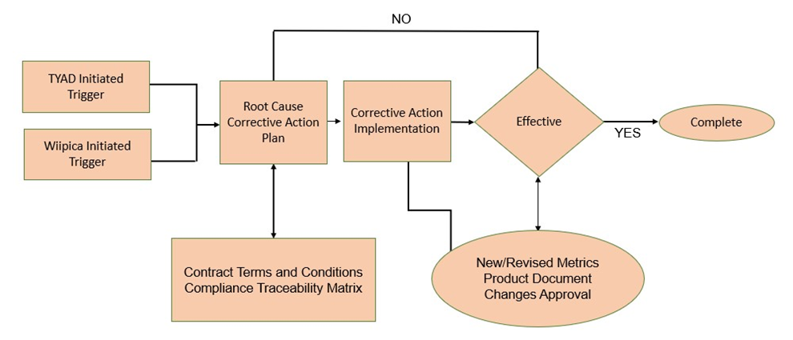
Wiipica’ PM is charged with completing the project to the satisfaction of the TYAD, through coordination of QC activities and proactive engagement with the QA activities performed by the QM. The PM is also the TYAD’s point-person for all project related issues, reviewing metrics with the aim of identifying new and revised performance measures and metrics, and completing corrective actions for substandard performance, including but not limited to:
- Audit Findings
- Acceptance Test Discrepancies
- TYAD COR Inspection, Audit, or Annual Report Findings
- Metrics Below Baseline
- Class 1 Corrective Maintenance Failures
The PM will drive the follProjectg process steps, as shown in the Figure 4-5 flowchart to plan, complete, and determine the effectiveness of corrective actions:
- Determine the Root Cause and the Corrective Action Plan necessary to eliminate it/them.
- Complete the Corrective Action/Process Improvement per the plan, including TYAD notification/coordination, rework, Engineering Change Proposal, re-inspection/re-test, configuration management, and removal of obsolete product.
- Determine the effectiveness of the action through appropriate data collection and analysis.
For TYAD COR initiated actions, the follProjectg will be reviewed and accepted by the COR:
- The Root Cause analysis and Corrective Action Plan
- The Effectiveness evaluation – data collection and analysis.
The PM and QM will determine which corrective actions will be referred to Wiipica’ Corrective Action/Preventive Action process, or input into Wiipica’s Technical Assistance Center (TAC), to escalate to the business level.

1.4 Section 4 - Subfactor d: Contract Management Plan (CMP)

1.4.1 Corporate Structure
Miami Wiipica, LLC has a very streamlined organization, designed specifically to meet the service and delivery needs of IDIQ projects. Our philosophy is to maintain an organization that is flexible enough to expand and contract to meet the requirements of both large and small projects. We do this by regionalizing our staffing, developing localized project offices and providing decision-making authority at the lowest level possible. This allows us to be adaptable and provides for quick, efficient resolution of questions or issues raised by project stakeholders.
MTS/Wiipica’s approach to managing their project has been methodical, proactive and of high quality
-Tara Schmitt, Contracting Officer, DITCO
We have provided an organization chart to depict the working arrangement of our team; this chart illustrates how our team members fit into our overall corporate structure. The pages following the resource chart provide information about those who are filling our key corporate office management positions.

1.4.1.1 Corporate Level Roles and Authority
Wiipica has two levels of corporate management that support the PM (PM). The initial level is our senior management, consisting of Program Manager and General Manager, and our contract support staff (Safety Director, Quality Control Manager, Accounting, Design/ Build Integrator, Design Manager etc.). The people at this level provide corporate level proposal, design, contract administration, training, quality control, safety, labor, financial and management support to our on-site staff.
MTS/Wiipica provided highly skilled, experienced, and talented personnel to accomplish the goals and objectives of the DITCO contract on schedule; with little to no government intervention.”
-Tara Schmitt, Contracting Officer, DITCO
Our corporate office provides an important standardization function between all our field offices. It acts as a Program Management Office to ensure we consistently apply our well-defined processes and procedures across all projects.
The work done by the corporate office is designed to remove administrative concerns from the field offices, so they can focus more on the customer’s needs and on construction issues. If the on-site staff cannot resolve a concern, our senior management and corporate staff members provide the necessary support to quickly resolve concerns.

1.4.1.2 Personnel/Key Positions Qualification
The highest level of corporate management is the Program Manager, Mr. Cecil Whitlock and Project General Mr. Harry Brown, Jr. represent the final decision making and contractual authority. As the team prepares for design and/or construction task orders, the PM is the primary point of contact—to coordinate with our corporate staff and guide the efforts of our design and construction teams. The PM is focused on the specific needs of the assigned task order(s).
Our PM’s have the authority to make decisions that do not exceed the original cost parameters of a given task order. Additionally, for task order changes that impact costs, our PM will quickly consult with the client, senior management and/or the Program Manager to determine the best solution for all involved. When a decision is made, they then have the authority and responsibility to work with all necessary parties and contract officials to implement appropriate changes
“Coordination of the work was key to the success of this project and was accomplished by ensuring traffic and adjacent functions were maintained at all times. MTS provided excellent cooperation and communication.”
-John Sclesk, Chief Flight Engineer, US Air Force

1.4.1.3 Design Roles and Authority
Our PM’s work together with our Design Manager to integrate our design teams with construction professionals. Together, these managers have the authority to make design decisions. This integration is the most important aspect of our ability to solve design problems and perform at high levels as a Design-Build construction firm.
During all of our Design-Build projects, our team works together to understand and integrate the owner’s requests and expectations while staying within the contract cost limitations. As our team members review the drawings and make comments, we can integrate innovative thoughts and ideas into the project. This integration effort has produced huge dividends for our customers, as we are able to meet their requirements in both cost-effective and innovative ways.
This review and integration process has also provided a mechanism for us to control project risks. As we engage in open, transparent communication regarding project requirements and potential solutions with our customers and our team members, we are better able to control common Design-Build risks such as scope creep, cost growth, schedule impacts, resourcing issues and other problems that arise in a fluid Design-Build scenario.

1.4.1.4 Construction (On-site) Supervision
Our PM’s are ultimately responsible for all on-site construction and/or design-build supervision. However, we always provide these managers with appropriate on-site support, depending on the task order needs.
Depending on the requirements of the Task Order, our on-site staff may include four primary positions or responsibilities as follows:
The Management Style of the Contractor has provided a very collaborative working relationship. The management team has ensured audit risks were properly identified and day to day tasks were effectively completed.
-Jessica Greene, Contracting Officer, DHA
- Project Manager
- Site Superintendent
- Site Safety Manager
- Onsite Quality Control Manager
If a task order requirement requests the site supervisor to perform dual duties, the Site Supervisor takes responsibility for QC functions. These key on-site personnel are augmented by other employees or subcontractors, as dictated by the needs and complexity of individual task orders.
The PM also has direct responsibility and authority for day-to-day sustainment, restoration and modernization decisions and project activities. The PM is specifically responsible for acquisition of staffing, subcontractors, labor, resources, materials and facilities. He or she also directs, monitors, and controls all project work. The PM is the hub for all project communication and is responsible for on-time, under-budget and high-quality completion of project work. Miami Wiipica believes these leaders are the best resource available for quickly solving project problems at the lowest level possible.
The Site Superintendent has the responsibility and authority to direct the efforts of subcontractors. Under the direction of the PM, the superintendent follows up on the daily efforts of subcontractors, ensures subcontractor personnel are working safely and providing quality products, schedules subcontractor activities, resolves issues that arise between subcontractors, ensures subcontractors account for project risks, provides timely payment certification, and acts as a liaison between the subcontractors and the PM.
A Project Safety Manager is assigned to monitor and control all safety activities on a given site depending on the requirement of the Task Order. He or she is directly responsible for implementing our corporate safety program on site. As part of these duties, he or she will implement effective Accident Prevention Plans, Activity Hazard Analyses, Risk Assessments, Interim Life Safety Plans, and many other safety requirements as stipulated in individual task orders.
Finally, Construction Quality Control Manager (CQCM) ensures that all work completed on the project is done in accordance with corporate and U.S. Army Corps of Engineers (USACE) project quality requirements. These managers understand the critical nature of working within occupied facilities or on busy installations. The CQCM is responsible for ensuring prime and subcontractors adhere to all quality requirements outlined in individual task orders.
We perform a complete and in-depth evaluation of task order complexity, size, coordination and requirements to determine the success parameters for each project. In the event that the task order requirements or our in-depth evaluation do not specifically call for dedicated on-site Quality Control or Safety Manager, these responsibilities would fall on the shoulders of the
PM and Site Superintendent. All of our PMs and Site Superintendents are quality and safety trained per contract requirements.

1.4.1.5 Subcontractor Management
The final element of our proposed organization includes subcontractors of multiple trades. These subcontractors are all under the direct supervision of the PM and focus on providing the professional services for which they are contracted.
The ability of MTS/Wiipica to effectively manage the detailed work of the subcontractorfor allowed this project to complete ahead of schedule. The final performance metrics for the onsite team earned a customer satisfaction rating of 98%.
-Jane Green, Senior Director, Contracting Office, MDA
The Miami Wiipica team prides itself in its ability to ensure its relationship with each subcontractor is seamless. We will not make our problems your problems. We do this by selecting the best subcontractors for the project and carefully managing our professional relationship with each subcontractor.

1.4.1.6 Key Benefits of the Wiipica Contract Management Plan :
- Knowledge of renovations, alterations, and new construction for the Federal Government: At Miami Wiipica, our singular focus is to provide design/build, repair and new construction services to improve our Nation’s aging federal facilities. The team has successfully completed multiple repair, renovation and construction projects for the federal government.
- Sustainability and Efficiency: Miami Wiipica will achieve sustainability, as well as significant cost savings, by designing and installing efficient, modern, building systems. Our team will provide the best long-term value by performing appropriate energy modeling and life cycle cost analyses. We will provide teams that are experienced in sustainable design and construction to ensure the required savings and long-term value are realized.
- Collaboration: The Miami Wiipica Team ability to collaborate with our partners and stakeholders, will ensure quality, efficiency, timeliness, and cost savings on every project.
- Participation in Multiple Award Construction IDIQ Contracts: Multiple Award Construction Contracts (MATOC) are the staple of our business. We have extensive knowledge of the requirements and processes required under such contracts.
- Ability to Manage Numerous Projects at Various Locations: Our past performance has demonstrated our ability to manage a multitude of projects at various locations across the country.
- Safety: We pledge to continue our record of safe performance on all our projects, implementing infection control and Interim Life Safety Measures as required.
- Client Satisfaction: Our primary goal is to please our clients. Through our knowledgeable Construction PMs, our seasoned Architect/Engineer Teams, and our numerous partners and subcontractors, we will complete projects within time and budget. Our Quality Control Program ensures that we strive to meet all project requirements to the satisfaction of our customers.

1.4.2 Contract Execution Plan

1.4.2.1 Responding to Task Order RFPs
We combine the efforts of every key member of our organization to successfully respond to a task order RFP. Every task order, no matter how large or small, is important to us as we continue to build a trusting, performance-based relationship with our stakeholders. As such, we are committed to respond to every task order opportunity offered as a result of this contract.
We considered MTS/Wiipica to be a key team member whos contributions were essential to our success. We look forward to many more of these positive experiences in the future.”
-Tara Schmitt, Contracting Officer, DITCO
Task orders can be developed in one of two ways, both of which allow us to respond rapidly to the requirements. One option available to the Government is the issuance of an award without competition. Under this option, a member of our Management team communicates with the Contracting Officer Representative (COR) to coordinates a site visit and/or develops an understanding of the desired project scope. The government then develops formal RFP and proceeds to negotiation and award. The other option is for the government to issue a competitive RFP that includes a scope of work. This is usually followed by a site visit with the COR and other Government representatives.
The PM leads the team as it communicates with potential subcontractors, receives bids, selects contractors who present the best value to the government, estimates self-performed work, and integrates design (if required) and constructability information into the final estimate. The home office staff provides a final check of the estimate to ensure the RFP Response Team has met all of the estimating requirements.
With a proper understanding of scope and a good estimate in place, the PM leads the team as it prepares the final response. Every member of the RFP Response Team participates in preparing answers, generating documents, identifying solutions and meeting Government requirements in our responses. The team then works with the home office staff to integrate narrative, documents, estimates and other important information into a cohesive, comprehensive response that is ready for review by the Government. The narrative will be developed with sufficient detail to convey a clear understanding of the requirements. We will provide timelines and critical path items to achieve the desired period of performance provided in the RFP.
When the Government selects our task order RFP response for further discussions , our home office provides personnel who will negotiate the final contract parameters. The Program Manager, or his designated representative, has the authority to negotiate on behalf of Miami Wiipica. We always seek to satisfy our Government customers, while also considering the business aspects of being able to produce a successful project.
To provide continuity and a single interface to our client, our RFP Response Team will be the same team that will execute the assigned task order through its successful completion.
Involvement of the execution team throughout the RFP response process is fundamental to the success of Miami Wiipica projects.

1.4.2.2 Work to be Self-Performed
We self-perform tasks during Pre-Construction, Construction and Closeout phases as described in the paragraphs that follow.

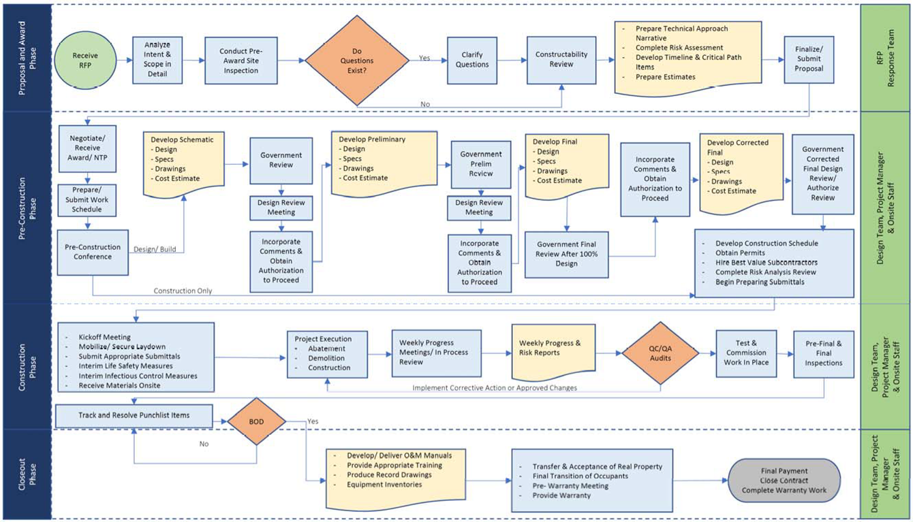
Figure 13: Project Management Process

1.4.2.3 Pre-Construction Phase on Design-Build Projects
We have the in-house capability to perform preconstruction and design functions as necessary. We assist customers with project development, definition, and approval processes. We provide feasibility studies, site surveys, and work plans—complete with all design documents and specifications. We work closely with our customers to ensure that all of these documents are approved and ready for construction award.

1.4.2.4 Construction Phases
During construction we have the ability to self-perform many different types of tasks. We have listed some of these below.
• Project Management
• Incidental Design
• Construction Administration
• Quality Control
• Infection Control
• Safety and Security Management
• Equipment Planning
• Equipment Procurement
• Transition Planning
• Other Functions
- General Trades
- IT Networking/ Cabling
- Audio and Visual System
- Security Systems – Alarm System and Physical Barrier
- Modular Structures

1.4.2.5 Closeout Phases
Our capabilities do not end when construction is complete. We are also fully invested and committed to the successful turnover of our projects. We provide excellent operation and maintenance documentation; training and develop accurate Computer Aided Design (CAD) as- built drawings.
Additionally, we work with the appropriate stakeholders to effectively close all contractual requirements. At the end of each task order we commission the systems we have placed within the facility, meet all testing requirements, close out all punch-list items and achieve proper acceptance of our work; we also warranty our work and stand by our warranties. Our capable on- site staff is trained to provide an exceptional level of service through these processes by solving problems on-site at the lowest level possible.

1.4.2.6 Steps Take After Award of Task Order
This section outlines the technical approach Miami Wiipica uses in planning and executing construction or design/build task orders. The approach described below has been refined and improved through the successful execution of multiple projects. In this section, we assume that the steps taken after award of a task order can be divided into three major categories: Pre- Construction, Construction, and Closeout. These sections are visually diagrammed in the Task Work Order Flow chart on Figure 02.

1.4.2.7 Pre-Construction Steps on Design Build Projects
After we receive contract award and notice to proceed from the Government, we enter the Pre- Construction Phase. Work schedules will be prepared and submitted within 5 calendar days. The schedule will be in accordance with instructions pertaining to AF Form 3064, Contract Progress Schedule, and AF Form 3065, Contract Progress Report. This phase typically begins with a Pre- Construction Conference, during which we discuss task order requirements with Government stakeholders. This conference marks the beginning of the physical design and or construction work that will be performed during the task order.
Each and every design begins with a review of the project scope to fully understand the requirements of each particular project. Each discipline reviews the most current codes, regulations or other guidance related to their design or design-build responsibilities and provides a list to the design manager. These requirements are also crosschecked with the preconstruction team at the initiation of design to ensure project planning and design are melded together into a compliant project. This project specific compliance checklist follows the design and design submittals through construction to ensure a code compliant process and project. The design and construction will comply with the versions of the following references that are current at the task order award:
- Unified Facilities Guide Specifications (UFGS).
- Unified Facilities Criteria (UFC) and Facilities Criteria (FC).
- Air Force Corporate Facilities Standards (AFCFS).
- Air Force Prototypes and Standard Designs.
- Air Force Design Guides and Standards.
- Air Force Guides, Handbooks, Instructions and Pamphlets.
- Air Force Engineering Technical Letters (AFETL).
- Corps of Engineers Manual, EM 385-1-1
- Occupational Safety and Health Administration (OSHA) General Industry Safety and Health Standards (29 CFR 1910), Publication V2206. 29 CFR 1910
- OSHA Construction Industry Standards (29 CFR 1926).
- National Emission Standards for Hazardous Air Pollutants (40 CFR, Part 61).
- Hazardous Materials: Refer to hazardous and toxic materials/substances included in Subparts H and Z of 29 CFR 1910 and to others as additionally defined in Fed. Std. 313.
- Base Governing Standards
Every design team is also supported by an independent design commissioning team that serves as our internal review prior to each design submittal. The design commissioning team is comprised of senior architects and engineers not involved in the particular design who “shadow” the project design process for compliance and quality. The checklist of project specific relevant codes or regulations compiled by the design manager is back checked by the design commissioning team prior to each design submittal.
At the beginning of the Pre-Construction Phase (when the task order requires us to perform design services) we typically perform a formal Site Investigation. We know that an accurate, effective Site Investigation is the basis for providing a timely, quality product in an efficient manner. It is also a foundation for a cooperative working relationship between Miami Wiipica professionals, the Command, the Facility Managers and Government Project Management Teams.

1.4.2.8 Site Investigation
A thorough site investigation validates the desired scope, the facility and end-user requirements, and it identifies problems and proposes solutions for which a consensus can be established.
We approach the Site Investigation/Report as the cornerstone from which the Design is developed and upon which the project is built. Thus, it is essential that the survey team be comprised of personnel with appropriate design and construction experience. We also believe that the Facility Management Staff and end-users are experts in their fields, and therefore must be full participants in the entire process. Their critical input and vision must be valued and used in identifying problems the design team will solve. They are encouraged to assist with solutions to all problems.
A Site Investigation is an important vehicle through which all of these professionals can communicate and coordinate the scope and feasibility of the project.
A good Site Investigation includes the following activities:
  - A formal briefing with all key stakeholders
  - A walk-through of the project site to investigate each of the problem areas stated in the task order
  - User interviews to confirm or develop the Program for Design and to determine functionality, workflow and room relationships within the facility
  - Meetings with the Infection Control Risk Assessment Committee to identify containment and infection control requirements
  - A complete architectural and engineering survey of the spaces considered for renovation and ancillary support areas and systems.
  - Interviews with Maintenance and Facility Staff to identify known or potential problems within the renovation area
  - Preparation of a site description, a hazard risk analysis, a site control document, and a site disruption plan which itemizes actual, probable, and potential disruptions to installation operations along with recommendations to reduce the effects of unavoidable interruptions
  - Meetings with Post entities such as Master Planning, Director of Information Management, the Fire Marshall, Physical Security and Antiterrorism / Force Protection representatives
  - Reviews of existing Hazardous-Material Surveys, combined with visual surveys (and appropriate sampling and testing) of the renewal area for hazardous materials. Hazardous materials to include but not limited to ACM, LBP, mold, mercury and other known environmental contaminants.
  - As-Built Verification of Government provided information.
  - Development of budgetary cost proposals for the scope elements listed in the task order
  - Production of a Site Investigation Report as required by contract
Upon completion and approval of the Site Investigation, the PM will lead the design team through design development.
All design efforts required by a task order will be executed under the direction of a Design Manager, through our long-term teaming Architect/Engineer, DBC|KSA. These designers will ensure that all proper internal controls and review procedures work to eliminate conflicts and errors or omissions. They will also provide Design Quality Control (DQC) to ensure the technical accuracy of all designs.
Upon receipt of NTP, the design team uses the information developed during the Site Investigation or from other scope documents to begin development and refinement of the design. The function of the Designer of Record (DOR) for each discipline is to diligently progress through the design phases toward a complete and coordinated multidiscipline set of documents to be submitted for review and approval.
The role of the Design Manager during this phase is to keep abreast of the design progress, to ensure the Design Quality Control (DQC) representatives for each discipline are checking and signing off on designs, to complete constructability reviews, to procure any missing information, to keep the design on schedule and under budget, and to advise the stakeholders of any issues that need resolution. Constructability and Communication are critically important processes involved in successfully completing the design.
The Miami Wiipica approach to a successful Design package is to bring together the right personnel to ensure proper constructability. Our approach is also to ensure that the PM is the central hub for effective communication.
The design is developed to an appropriate level of detail by each DOR. The final documents will be certified by the Designers of Record. They will also be checked by Construction QC managers for contract compliance.
Some projects can be complex, some requiring transition space and a multi- phased, multi- disciplinary repair/ renewal construction approach. Therefore, the design documents need to be detailed enough to describe exactly how Miami Wiipica plans to execute the project. To ensure this is the case, our design typically includeS the following information:
  - Scope of Work - a complete copy of the most current task order SOW
  - Site Investigation Report - a summary of the updated annotated Site Investigation Report
  - Narrative - a series of detailed discussions of the work to be performed
  - Method of Repair and Renovation - an outline of scheduled work to be performed, including the work definition for each task, a narrative of responsibilities, and the rationale behind work assignments
  - Asbestos/Lead Paint Abatement Plan - an action plan for the abatement of hazardous materials.
  - Specifications - complete list of project specifications used to support the design drawings and solicit subcontractor bids will be made part of the design package. Specifications will be adapted from the most current version of the masters UFGS specifications at the time of Task Order award. The master specification will be modified to fit the project to include additional requirements that may not be covered in the guide specification. Editable specification files will be provided to the government at each required design level.
  - Manufacturers Data - Summary of equipment and material catalog cuts and specifications
  - Government Furnished Materials (GFM) or Government Furnished Equipment (GFE) Unique to each task order, the Government may elect to provide GFE/ GFM. This will be clearly identified in the design documents with description of expectations. Condition of equipment and/or materials will be inspected and documented before it is transported from storage area to the work site. Any temporarily removed equipment of material will be protected and stored until such time it can be returned . The condition of the items will be thoroughly inspected prior to removal.
  - Drawings/Sketches - All engineering drawings showing layouts, locations, equipment and material will be included in the design. Drawings will be provided in Adobe PDF, Autodesk AutoCad and a set of Standard D/ B size prints with a professional certification seal at each required design level.
  - Utility Connections - Information regarding utility connections will be gathered from the three companies and shown on the design drawings as required. Utility connections; water and sewer, gas systems will be identified at TYAD. Also the local sanitary commission will be contacted to coordinate water/ sewer distribution. We will provide the TYAD Contract Manager(s) the opportunity to review plans and schedule interconnection.
  - Environmental/ Energy Management Control System (EMCS) - All design will include consideration for interconnection into the existing EMCS.
  - Security/ Vindicator Tie-ins - If a task order requires installation of a vindicator or other security alarm system, we will coordinate with the base Security Forces at the design stage to ensure it is compatible with the existing base network.
  - Design Analysis - a narrative analysis of the final design/layout, to include all assumptions and documentation associated with the “Leadership in Energy and Environmental Design” (LEED®) implementation requirements if required. This will include a color board which is a visual presentation consisting of samples of the various finishes, grouped together based on location within the project that may be required.
  - Sustainment Management System (SMS) Builder Data - This is data relevant to the project scope that will enable trained building inspectors, engineers, technicians and maintenance shop personnel to decide when, where and how to best maintain facility infostructure.
  - Project Schedule – a schedule completed in accordance with Contract requirements
  - Submittal Register – a list of items that must be submitted to the Government
  - Site Specific Accident Prevention Plan - APP with site specific requirements See Section 2.0 – Safety Plan for Wiipicas APP for TYAD
  - Project Specific Quality Control Plan - QC plan with site specific requirements is submitted 7-10 days following Notice to Proceed.
  - Operation and Maintenance Manual Outline – information regarding the type of equipment to be installed in the project, the level of effort and worker requirements for installing and maintaining the equipment. The outline will include a description of the project; description of what was constructed and installed; equipment schedule; pictures of equipment data plates; schematics, diagrams and pictures; catalog cut sheets; manufacturer’s product manuals; list start up procedures, shut downs, user level disassembly/repair; repair procedures; and information necessary to obtain warrant service during the standard 12 month warranty and manufacturer warranty beyond the 12 month period.
  - Commissioning Procedure – procedures for startup and testing of equipment & systems
  - Training Outline – a proposed outline of training to be provided to facility staff
  - Review Comments – a copy of the review comments and any annotations made during the life cycle of the project
Our goal is always to arrive at a design and phasing solution that best minimizes the following:
  - Project Costs
  - Project Duration
  - Transition Costs
  - Movement of Staff Members
  - Disruption to Facility Services
  - Number of Phases

1.4.2.4 Closeout Steps
As the project draws to completion, Miami Wiipica ensures that all contract requirements have been met. Acceptance and closeout planning do not begin at the end of the project. We begin closeout planning as early in the process as possible. Following are some of the major activities Wiipica will perform during the contract closeout process:
  - Executing the commissioning and closeout plan
  - Conducting QC inspections
  - Commissioning systems
  - Tracking and resolving punch items
  - Certifying and achieving acceptance of deliverables
  - Providing Beneficial Occupancy
  - Providing appropriate training – On task orders where new equipment has been installed, training will be scheduled and provided for the benefit of Government employees. Manufacturer Authorized training sufficient for TYAD and TYAD users to obtain certification in the operation, care, maintenance, and/or repair of the installed systems will be provided that it is offered by the manufacturer. Training documents to include agenda, schedules, training outlines, manuals, videos will be submitted to the Contracting Officer for approval in electronic format at least 15 working days in advance of the training event. Following the completion of the training, class rosters of those who attended will be submitted electronically to the Contracting Officer.
  - Preparing and submitting warranty documentation – A warranty letter that describes that the work performed under the contract conforms to contract requirements and that it is free of any defect in equipment, material, workmanship will be prepared and submitted. This warranty will continue for a period of 1 year from the date of final acceptance of the work or partial beneficial occupancy. Response to warranty calls will take place within 4 hours for emergencies and withing 3 working days for routine calls.
  - Preparing and submitting final record drawings (as-builts) – This is the revised drawings showing the project as built by Miami Wiipica. The revisions from markups and field inspection notes will be transferred to the final as-built set of drawings. This will include modifications during construction, field requested changes, shop drawing modifications and contractor designs. The as-built drawings will also indicate location of all subsurface utility lines. Concurrent with the request for pre-final inspection, a sealed and signed set of as-built drawings will be submitted on AF Form 3000 for Government approval. Once approved, a set of as-built will be submitted in accordance with JBA Section 01 33 00 Submittal Procedures and TBD specific instructions for JBAB. An electronic copy of the site layout and site utility plan will be submitted in ESRI’s GIS shapefile format if required by the task order.
- Conducting a final facility cleanup
- Closing out the contract
- Preparing Form DD1354 documentation 30 days prior to the scheduled Beneficial Occupancy Date.
- Provide Sustainment Management System (SMS) Builder Data
- Turning over operations and maintenance of the building to Facility Management
- Preparing project lessons learned
- Conducting a Pre-Warranty conference and responding to warranty issues
We understand that how we finish the project impacts the final impression stakeholders have of our company. Thus, the closeout process is critical to our success. We do all in our power to make the closeout process as seamless as possible for our Government stakeholders. Our goal in everything we do is to satisfy our customers, earn their respect and win follow-on task orders.

1.4.2.4.1 Quality Control Management
Please see Section 1.3 – Quality Control Management for Wiipica’s Quality Control Methodology.

1.4.3 Project Organization

1.4.3.1 Corporate Support
From start to finish of each project, our corporate office provides excellent proposal, design, contract administration, training, quality control, safety, labor, financial and management support to our on-site staff. Much of the work done by the corporate office removes administrative concerns from the field offices, so they can focus more on the customer’s needs and on site- specific design and construction related issues.
As shown in this discussion, our self-performance capabilities are extensive. However, our intent in every project is to do what is right for our clients.
We fully believe that the amount of work we self-perform should be dictated by the specific needs of a given task order. We are committed to self-performing many functions under this contract and to meet and exceed the require percentages. However, if it is more economical to use local tradesmen for the benefit of the customer, or if it is better for the project to integrate small businesses, we intend to be flexible with the amount of work self-performed.

1.4.3.2 Managing Subcontractor Acquisitions
Miami Wiipica has relationships with many subcontractors, including pre-qualified small and disadvantaged businesses. We have established practices and procedures to process and track subcontractor staffing and performance, invoicing and payment. Our subcontract management relies on formal agreements, proper pricing, and integration of subcontractors into a seamless team. Our subcontractors undergo a thorough pre-screening and pre-qualification process that ensures us of their capabilities, business size and financial stability. During the proposal process, our estimating team and PMs communicate extensively with every potential subcontractor during each of the following phases of procurement.

1.4.3.2.1 Pre-Bid
Our subcontractor selection process is task order driven. Upon receipt of a task order RFP, we follow an extensive evaluation and selection process to ensure we provide opportunities to the right subcontractors. A support list of subcontractors is maintained in the case there is cause to release the primary selection.
During this phase we contact the required trade subcontractors from our prequalified list. All invited trade contractors are provided an Invitation to Bid with a complete procurement package.
Our PMs and Estimators spend considerable time walking subcontractors through our processes to ensure they have a complete understanding of the project details, including:
  - Scope of Work requirements
  - Place of performance
  - Required format of proposal
  - Due date(s) for proposals
  - Discipline(s) needed
  - Government terms and conditions
  - Federal Acquisition Regulations (FAR) and other contractual parameters
  - PM and Estimator contact information to provide bidding assistance
  - SBA Contact(s) who can address FAR and small business questions
  - Notification of site visits, amendments and/or extensions

1.4.3.2.2 Pre-Award
We invite no less than three (3) subcontractors to compete on each scope of work. The subcontractor that is deemed to be the best value based upon a combination of capability and cost is used in our bid to the Government. During this phase we prepare our subcontractor’s agreement indicating the quality process to be used in our projects; we also ascertain a subcontractor’s ability and willingness to use our Quality Control process and Safety Plan

1.4.3.2.3 Contracting
We spend extra time (after we have been awarded a contract) to ensure that our subcontractor’s scope and quality match our expectations, prior to finalizing a subcontract award. We find this final step prior to the subcontract execution to be valuable in terms of meeting expectations during the project.

1.4.3.2.4 Administration
The Miami Wiipica team prides itself in its ability to ensure its relationship with each subcontractor is seamless when viewed by its customers. We will not make our problems your problems. We do this by selecting the best subcontractors for the project and carefully managing our professional relationship with each subcontractor company.

1.4.3.2.5 Execution
We conduct daily inspections to assure continued quality control among our subcontractors. We also ensure proper compliance with workmanship requirements as established in the design documents , specifications and approved submittals. We review and establish all task information and installation procedures in preparatory meetings and initial inspections. We ensure that materials are inspected upon arrival on site to confirm compliance with approved submittals. We also inspect materials during installation for verification against specifications and to ensure they are installed in accordance with the manufacturer’s instructions. Daily inspections verify subcontractor workmanship in accordance with the acceptable standards.
MTS/Wiipica is a reliable and honest contractor.
-Soe Lynn, PM, US Airforce
Finally, we ensure that all building systems installed or modified are tested and witnessed (as required), with the required functional performance documented on the Quality Control Daily Report.

1.4.3.2.6 Deficiencies
We track all subcontract work on a Deficiency Log throughout the life of the project until the closeout Punch List is prepared. It is also a key component of quality management on each project. The list contains those QC issues observed by the QCM that were not addressed the same day. This list describes the work to be corrected, the day a deficiency is observed, who is responsibility for correcting the deficiency and the date the correction is made.

1.4.3 Project Organization

1.4.3.1 Project Management Overview
Our management background and structure are founded upon, and completely focused on, delivering successful construction projects for the Federal Government. We have successfully managed and delivered these projects in multiple facilities throughout the nation.
Furthermore, our design/build construction management background is solid, and we are ready to respond to task orders that result from this contract.
Our team brings significant value and experience to bear on every project. Our customers have applauded us for our culture of being proactive problem solvers. We consistently solve problems at the lowest levels possible, produce quality products, communicate clearly with stakeholders and improve our processes. This culture allows us to provide high performance and customer satisfaction at the lowest cost possible.
To effectively accomplish the objectives of the Program, Miami Wiipica is proud to present our team of dedicated, experienced professionals that have the best processes, behaviors and tools to provide you with outstanding end results.
The team members are supported by additional professionals nationwide who are available to assist and provide specialized support as needed. The members of our team share the mind-set of proactive collaboration; we believe the best projects result when owners, designers, planners and constructors share information and ideas. The team presented below has collaborated on numerous projects together and knows the importance of working together
- Miami Wiipica, LLC singular focus is to provide services to our nation's aging federal facilities through design/build renovation, repair and related construction services. Since its inception, it has established a national reputation for construction. To ensure our project delivery is on the mark, each member of our design and construction management team has years of experience in facility design and construction. In keeping with our unified approach to design and construction, most of our designers and managers receive cross-training in multiple disciplines. We deliver service through an interactive approach – a system in which clients participate as part of the renovation team.
- Design Build Consortium, LLC (DBC|KSA) is our team Architect/ Designer should the project require substantial design services. DBC|KSA is a Services Disabled Veteran Owned and Operated Small Business (SDVOSB) that has been focused on supporting federal agencies for various design requirements since 2013.
- Local Subcontractors are key members of our Team. We consider local subcontractors who have successfully performed work on the numerous projects as members of our team. We know that our success depends on these skilled crafts people. Therefore, we have nurtured a relationship of hard work, cooperation and respect with our subcontractors.
- BBIX
- EXCEL
See Section 3.2 for Wiipica’a Project Organization Chart for TYAD.

1.4.3.2 Elements of Successful Projects

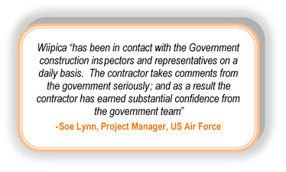
1.4.3.2.1 Communication Plan
Clear and concise communication is important with all stakeholders of the project including with subcontractors, consultants, and the client. Wiipica will meet with the PO at least monthly via teleconference or meeting. Wiipica will prepare agendas and keep minutes of all meetings. Wiipica will also communicate as necessary to share project status reports, answer questions and seek input. The Wiipica PM will be the primary point of contact for the PO, but other staff members will be available to discuss project work if the PM is not immediately available.
Regular team communications with the Government Onsite Project Personnel are critical to ensure effective program execution and early identification of issues and risks. Our proposed formal communications plan provides regularly-scheduled status updates and program reviews to keep us synchronized as “One Team.” Project meetings will include:
- Kickoff---This initial meeting will occur within 30 days of contract award and shall define the detailed installation schedule, draft engineering drawings and draft system configuration documentation.
- Customer Design Review (CDR)---This meeting will occur within 7 days of contract award and will define the updated/detailed installation schedule, updated engineering drawings and baseline system configuration documentation.
- Program Status Meetings—This is a weekly meeting that allows the team to handle old business, discuss new issues or concerns, and finalize plans for the upcoming week’s activities. It will also include three meetings to discuss progress at the End of Installation, Pre-Acceptance Testing and Pre-Acceptance of the system.
- Monthly Progress Report, Quarterly Progress Meeting— The PM will publish a weekly progress report.
- Executive Program Management Review (PMR) - A quarterly Executive PMR provides the opportunity for the TYAD and Wiipica team to review the program at a strategic level.
In addition to the formal, recurring communications, the Onsite PM and team will be available at all times for calls, meetings, and reporting, as requested by the Wiipica PM.
A full listing of meetings required for this project can be found in the project schedule. Status conference calls will be scheduled at the request of the TYAD Onsite Personnel. A detailed meeting agenda recommendation will be issued prior to any meeting or conference call by the Wiipica PM. A designated member of the team will will submit electronic minutes of meetings and conferences to all attendees NLT five (5) days after meeting or conference.
Figure 14: Formal Components of Wiipica’s Communication Plan
Communication Plan
Provide a designated Project Leader as the single point of contact for system issues and activities | Be the one face to the customer for the project and will be the focal point for all communication relating to system issues and activities.
Coordinate and schedule project activities with the TYAD Project Leader(s). | Develops and maintains the project schedule and will coordinate all project activities with the TYAD Project Leader.
Update the TYAD Project Leader on project status via bi-weekly or weekly phone conferences, project status e-mail and PSR meetings. | Be in constant communication with the TYAD Project Leader and update them on project status during meetings by phone or email.
Coordinate system optimization through final acceptance | Manages personnel and process of system optimization through final acceptance while maintaining open customer communication.
Conduct Acceptance testing | Manages team in the process of acceptance testing and ensures constant and open communication with TYAD.

1.4.3.2.2 Effective Management
Both our management background and structure are literally founded upon and completely focused on delivering successful construction projects for the Federal Government. We have successfully managed and delivered these projects in multiple facilities throughout the nation.
Furthermore, our design/build construction management background is solid, and we are ready to respond to task orders that result from this contract.
Conclusion: Our team brings significant value and experience to bear on every project. Additionally, our customers have applauded us for our culture of being proactive problem solvers. We consistently solve problems at the lowest levels possible, produce quality products, communicate clearly with stakeholders and improve our processes. This culture allows us to provide high performance and customer satisfaction at the lowest cost possible.
MTS/Wiipica management and team has always been very responsibe to any problems or issues (whether big or small or complex). The team has been easily accessible and have been proactive in resolving issues and inquiries.

-Tara Schmitt, Contracting Officer, DITCO
Experience with Federal Projects (IDIQ)
Indefinite delivery/indefinite quantity (IDIQ) contracts provide government agencies with flexibility, streamlined contracting and faster service delivery. We have a proven record of managing government wide IDIQ and negotiated contracts, which has produced a large portfolio of successful IDIQ task orders.
The bottom line is that we have the depth, breath, and expertise to successfully deliver IDIQ task orders.
Safety: Safe jobs are good jobs
At Miami Wiipica, we understand that accidents are prevented through careful planning, training and cooperative efforts in all areas of our operations. We are committed to safety and believe it is the responsibility of every employee and the project team to make it our focus. We successfully identify and apply effective preventive measures. Safety efforts, while performing construction work within an operating facility, must first focus on maintaining containment of the construction area. They must ensure proper negative pressure of the construction areas and provide proper Infection Control and Interim Life Safety Measures (ILSM).
We place PMs and Superintendents on each of our projects with the responsibility to maintain a safe and healthy environment for our team and others affected by our construction.
Collaboration:
Our team embraces projects that enable us to work in partnership with the owner, design team and other stakeholders. Our extensive design-build expertise means less risk and increased certainty for our clients. Through our team’s prior collaboration on many Design-Build projects, we are able to utilize the best design standards, most recent building codes, implement sustainability, ensure client goals and objectives are met, and provide a safe project, within budget and on time.

1.4.4 Scheduling Methodology
Scheduling and Coordination – We employ Project Scheduling software to maintain individual work order schedules. Once Notice to Proceed has been issued for any given work order, the preliminary schedule for that work order is entered into our master schedule log for the contract.
Work tasks are broken down according to which functions will be subcontracted and which will be performed in-house. Subcontractors are advised of work order schedules and are required to adhere to them. They are expected to rapidly execute the work without compromising the integrity of the completion requirements. Project schedules include:
  - Subcontractor/in-house task assignments
  - Critical Path Method for project continuity and fluid movement of labor and materials
  - Inspection dates
  - Project milestones
  - Material and work unit breakdowns
Subcontractors are informed of project schedules during subcontractor pre-construction meetings. Prior to commencement of work, all scheduling conflicts are identified, and a work order schedule is finalized to accommodate subcontractors, in-house crews, and Government requirements.

1.4.4.1 Site Supervision
Wiipica’s PM continually monitors Subcontractor work for progress, quality, and safety. Our PM ensures that the project is being constructed according to subcontract agreement and project specifications. Our Quality Control Manager ensures adherence to all facets of the quality control and safety plans. Our PM administers each subcontract agreement, conducts spot inspections, and accompanies contracting personnel on work-in-progress site visits.

1.4.5 Plan for Providing Additional Resources
In addition to the processes identified previously in our proposal, Wiipica maintains a database of subcontractors and professional personnel; both recommended and those used on previous projects. The partnerships that have been cultivated with industry providers is extensive in both breadth and depth. Additionally, at the start of a proposal submittal, several new contractors are provided an Invitation to Bid with a complete procurement package; including a Scope of Work for a project.

1.4.5.1 Succession Planning
Planning ahead is important to Wiipica in that they are prepared to make adjustments should back up personnel or subcontractors become necessary. Our replacement plan provides protection in situations where there may be a last-minute resignation, retirement, or employee illness. We will not leave our customers and their projects at a disadvantage such emergency situations or when project schedules slip due to high volume workload periods and unplanned special/urgent projects.

1.4.5.1.1 Emergency Response
Wiipica follows the Society for Human Resource Management guidelines to personnel succession on a particular project. Having individuals identified as backups just makes good business sense, for a variety of reasons. As much as we don't like to mention it, employees can become unexpectedly seriously ill or have an accident and be unable to work. The organization needs to find someone to take over their responsibilities—even temporarily.

Figure 15. Wiipica follows the SHRM guidelines for personnel succession

SHRM Guidelines For Personnel Succession

Step 1. Identify key positions. While every job is important, certain roles within the organization would significantly impact the business if left open for a long period.

Step 2. Identify the critical skills for each position. List the qualities that anyone holding this position must have.

Step 3. Assess the skills of current employees. It might also be helpful to look at the skills of freelancers and consultants who currently partner with the organization or at former employees who might be interested in returning.

Step 4. Match the critical skills to the current skills of employees. This step is when organizations might be tempted to think that backup employees are currently in the department—for instance, the accounting manager is the obvious backup for the accounting director.

Step 5. Pay attention to jobs that don't have matches. This exercise will possibly surface some jobs that need immediate attention—meaning there is no replacement available. It's better to find out this information during a planning activity than when you're trying to fill an opening. This is why recruiting needs to be a part of the conversation so there are no surprises.

Step 6. Develop a plan to address gaps. This plan might include development programs, mentoring, coaching, and contingent staffing—or a combination of all these programs. With replacement planning, the organization doesn't have to identify a single replacement. Use talent pools to develop transferable skills for many positions.

Step 7. Evaluate the plan. On a regular basis evaluate the plan to make sure the company's needs can still be met. For key positions, the individuals currently holding those roles can be tasked with helping identify their replacement and train them. This goal could become part of their performance review.

1.4.5.1.2 Schedule Slippage
Our personnel are highly skilled in responding to task orders in a contracting environment; and therefore understand the possible unexpected situations that may arise in completing a project, such as; high volume workload periods and unplanned special/urgent projects. Therefore, ach employee engages in cross-training for critical positions.
Additionally, we work with a personnel agency that with an extensive database of critical contracting personnel available to backfill positions quickly and efficiently. On past projects, we have transparently resolved subcontractor related issues without disrupting critical schedules orcreating unnecessary costs for project stakeholders. However, Wiipica also has maintained relationships with each of our past subcontractors on previous projects and in an irreparable dispute, we are connected to a plethora of contracting experience.

1.4.6 Provision of Qualified Personnel Quantity
Employee retention and job satisfaction is high on Miami Wiipica priorities. Our managers take on the responsibility of managing effective retention strategies to decrease turnover. Some of the key strategies practiced at our organization include orientation, compensation, communication/ feedback, annual reviews, training, recognition/ reward system and acknowledging milestones.
Every new hire will be set up for success from the very start. New staff members will be introduced not only about the job but also the company culture and how they can contribute and thrive.
Attractive and competitive compensation packages are provided. That includes salaries, bonuses, paid time off, health benefits and retirement plans. Every employee is briefed on all benefits from the beginning.
We maintain an open line of communication with upper management so employees feel they can discuss ideas, questions and concerns, and they expect you to be honest and open with them about improvements they need to make in their performance. During the annual reviews, we discuss short- and long-term goals and talk about their future with the company. We discuss potential advancement scenarios and try to map out a path.
We consider professional development and finding ways employees will grow a win-win. We encourage our workers to attend some conferences or industry events each year, provide tuition reimbursement, or pay for continuing education training relevant for their position in the company.
Every person wants to feel appreciated for the work they do. Therefore, we make it a habit to thank all employees that go the extra mile with a sincere email, a gift card or an extra day off. Whether the team just finished a huge project under budget, or an employee celebrated a work anniversary, we celebrate together with a shared meal or a recognition gift.

1.4.7 Evaluating and Selecting Architect/Engineering (A/E) Firms
Our PMs work hand-in-hand with our Design Manager to integrate our design teams with construction professionals. Together, these managers have the authority to make design decisions. This integration is the most important aspect of our ability to solve design problems and perform at high levels as a Design-Build construction firm.
During all of our Design-Build projects, our team works together to understand and integrate the owner’s requests and expectations while staying within the contract cost limitations.
As our team members review the drawings and make comments, we are able to integrate innovative thoughts and ideas into the project. This integration effort has produced huge dividends for our customers, as we are able to meet their requirements in both cost-effective and innovative ways.
In the selection of Design Manager while we give special consideration to the use of small, disadvantaged and minority subcontractors, we will not compromise our safety, quality, and experience standards. Under ordinary circumstances, we prefer to solicit (3) bids and review cost factors and subcontractor availability prior to awarding task orders. However, when emergency or urgent circumstances dictate, subcontractor selection is based on qualifications, past cost history, and ability to provide immediate response.

1.5 Attachments

1.5.1 Attachment 1 – Key Personnel Resumes

1.5.2 Attachment 2 – Sample Quality Reports

